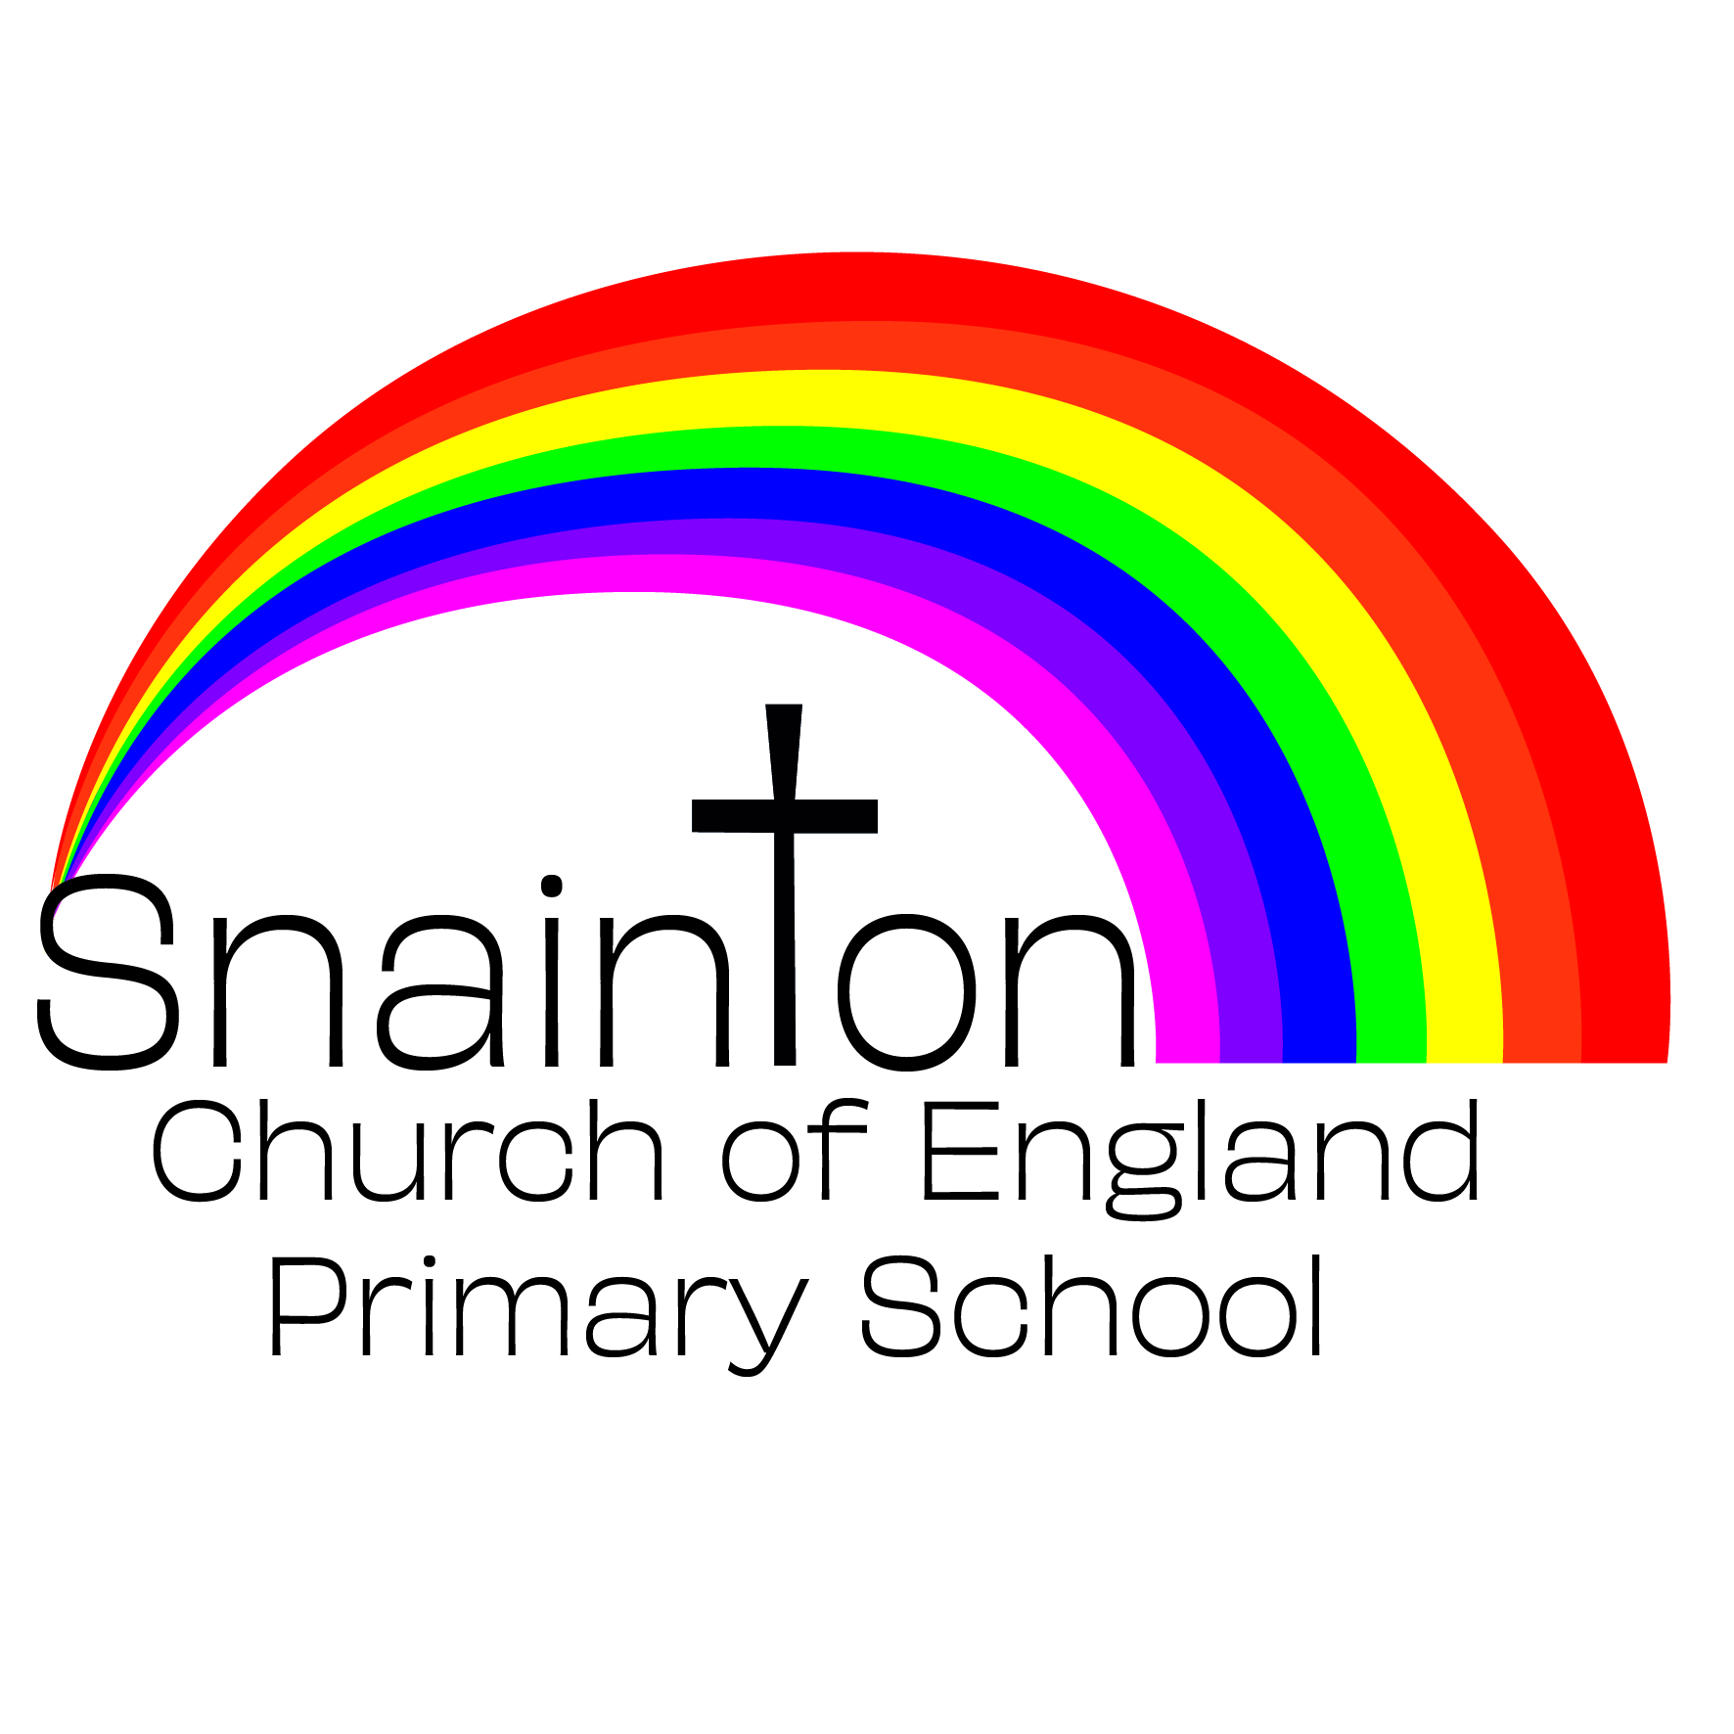

Belong Believe Become
“Do not be afraid: keep on speaking, do not be silent. For I am with you”
Acts 18:9-10

Uniform policy

Approved by governors: 13th July 2020
Date for review:

Rationale
We believe that a school uniform is important for all of our children. It is thought that our uniform appears to be smart and well-presented and it helps to create a sense of belonging to our school community. Our children feel proud to wear their uniform. We also understand that a school uniform can help prevent feelings of inequality by comparing to how others may appear in branded, casual clothing.

Our school uniform is designed with our broad curriculum in mind and is suitable for the range of school activities that all children enjoy during their time in school. Many aspects of our school uniform can be purchased ‘off the shelf’ for a modest cost. We intend for our uniform to be cost-effective, without creating unnecessary burden for our families. There are items available with the school logo attached through our school website but these are not compulsory.

Uniform
Black/grey trousers
Black/grey shorts
Black/grey skirt
Black/grey pinafore
If tights are to be worn they must be black/grey
Red polo shirt
Navy blue jumper (with or without school logo)
Navy blue cardigan (with or without school logo)
Blue summer dress (in warmer weather)
Black shoes
Plain black boots (in colder weather)
Book bags are available with the school logo but are optional

Ear piercings are permitted. Children must wear stud earrings for school.
All other jewellery is not permitted in school eg, necklace, bracelets.
A watch is permitted to be worn.

PE Kit
Plain black shorts
Plain white t-shirt
Trainers
Navy blue joggers (for cold weather)
Navy blue jumper (for cold weather)

Long hair must be tied back with a bobble for PE.
All earrings must be removed or covered at home with a plaster for PE.
A watch must be removed for PE.

Forest School kit
The general expectation for Forest School is to wear a number of thin layers of clothing which can be added/removed throughout the day. Children can arrive to school wearing their Forest School clothing on the day itself. Parents and carers will receive a text message reminder the day before Forest School.

Tracksuit/jogging bottoms
T-shirt
Jumper
Wellington boots/old trainers
Waterproof coat, gloves, scarf and warm hat (in poor weather)
Sun hat (for sunny days)

