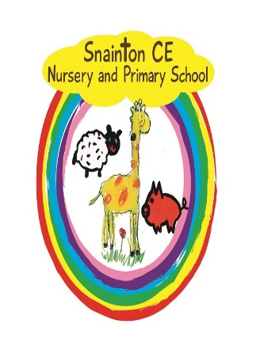

Belong Believe Become
“Do not be afraid: keep on speaking, do not be silent. For I am with you”
Acts 18:9-10

Nappy Changing Procedure

Approved by governors: 11th November 2019
Date for review: November 2022

- The child/toddler will be placed safely while staff wash their hands
- Staff MUST wear disposable gloves & apron
- Child placed on the changing area
- Wet/soiled nappy removed
- Baby/child cleaned from front to back and barrier cream may be applied
- Clean nappy placed on child
- Wet/soiled nappies and all cleaning materials will be bagged and disposed of in the nappy bin.
- Staff to remove gloves and apron which must be disposed of immediately by placing in a rubbish bin.
- Child returned to room
- Staff clean mat with disinfectant spray and wipe down with paper towels.

