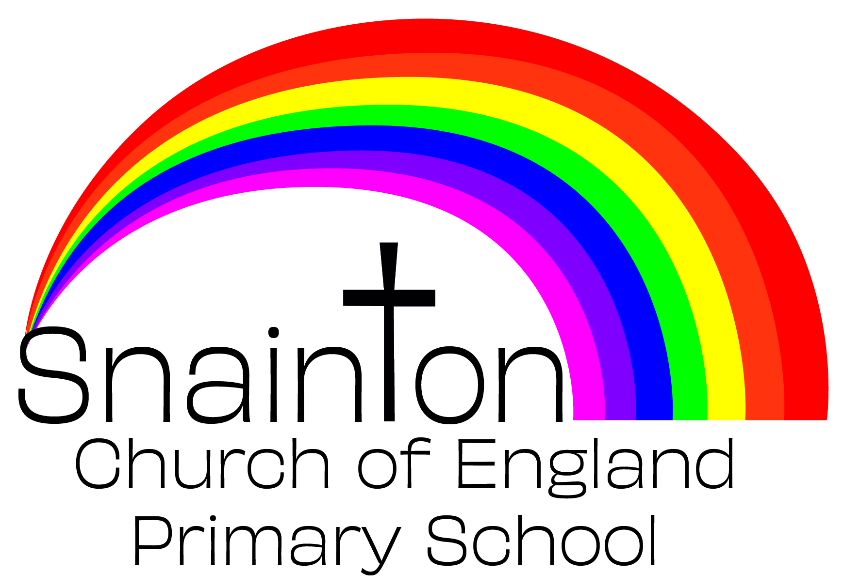

Remote Learning Plan
In September 2020, the Department for Education outlined the following expectations of mainstream primary schools in case of a further Covid-19 outbreak:
‘For individuals or groups of self-isolating pupils, remote education plans should be in place. These should meet the same expectations as those for any pupils who cannot yet attend school at all due to coronavirus (COVID-19).

In local areas, where restrictions have been implemented for certain sectors (from national direction), we anticipate that schools will usually remain fully open to all.

However, there may be exceptional circumstances in which some level of restriction to attendance at schools is required in a local area. The Department of Health and Social Care (DHSC) has updated their Contain framework to include an overview of the tiers of intervention for education settings when managing local outbreaks and implementing restrictions.’

In response to these expectations, Snainton Church of England Primary School has devised this plan to ensure remote learning opportunities are available to all pupils, when required.

This plan will be implemented in the following instances:
- An individual is self-isolating because of a positive test/there is someone with symptoms within the household
- A group of children are self-isolating because of a case of Covid-19 in the bubble
- A whole bubble is self-isolating because of an outbreak of Covid-19

Remote Learning
School has setup login details for all pupils using MS Teams. This will provide the main focus for our remote learning strategy. Where a family do not have the relevant equipment at home to facilitate this, school will either provide a laptop and internet dongle or provide a home learning pack of printed resources which are very closely matched to the remote learning offer.

Pupil needs to isolate because someone in their household is symptomatic or tests positive
Ongoing Support | Safeguarding/SEND
Class teachers will upload assignments to MS Teams for pupils to access remotely. This will include instructions to support learning and may include a video link using MS Teams to allow for virtual teacher input. In this case, only the input will be included in the video. Pupils will then complete work independently. The class teacher may direct pupils to online materials available through Oak Academy, White Rose Maths and Literacy Shed to support remote learning.  Pupils working remotely can submit their assignment for teacher feedback. This feedback will provide next steps/support as required and may include a follow up meeting using MS Teams to ensure learning is secure. | School office to contact parents to ensure a test has been taken and to make sure that parents know to communicate test results to headteacher@snainton.n-yorks.sch.uk  If child is entitled to benefit-related Free School Meals ensure food is made available through the school kitchen.  If child is vulnerable in any way, the DSL will ensure that appropriate agencies are notified and arrange for regular safe and well checks via a phone call from the DSL.

A group of children are self-isolating because of a case of coronavirus in their bubble
Ongoing Support | Safeguarding/SEND
Class teachers will upload assignments to MS Teams for pupils to access remotely. If teaching input is required for core lessons, the teacher can either direct the parent to a relevant Oak Academy taught session or they could use MS Teams to teach directly to the isolated group of children at the same time as teaching to the rest of the class.  Once the input is complete, the Class teacher will briefly discuss the learning with the isolating children via Teams before ending the conversation.  Pupils working remotely can submit their assignment for teacher feedback. This feedback will provide next steps/support as required and may include a follow up meeting using MS Teams to ensure learning is secure. | School office to contact parents to ensure a test has been taken and to make sure that parents know to communicate test results to headteacher@snainton.n-yorks.sch.uk  If child is entitled to benefit-related Free School Meals ensure food is made available through the school kitchen.  If child is vulnerable in any way, the DSL will ensure that appropriate agencies are notified and arrange for regular safe and well checks via a phone call from the DSL.  Those not engaging with home learning will receive a phone call from the class teacher to discuss any obstacles and to provide support.

A whole bubble of children is isolating because of an outbreak of coronavirus
Ongoing Support | Safeguarding/SEND
Class teachers will schedule a MS Teams meeting with the children and parents for the following day (after isolation). In this meeting the teacher will discuss the remote learning arrangements and expectations. Teachers will also share a timetable of learning – this will consist of core subject lessons and a whole class reading session per day.  Teachers will create assignments using MS Teams for pupils to complete each day. These must be submitted for feedback from the class teacher.  The Class teacher will share links to appropriate lessons from White Rose Maths or Oak National lessons through the assignment. Teachers will then be accessible to children through Teams so that any issues or re-teaching can be delivered live.  Teachers will share ideas for further home learning to cover non-core subjects. These will consist of projects that can be completed at home that link to the class topic.  Completed work should be photographed and uploaded to MS Teams. Teachers can then review the work completed and ensure that the following day’s lesson addresses misconceptions etc. Feedback and queries can take place throughout the day using MS Teams. Those children that need additional support following feedback are to be directed to the MS Teams meeting for that lesson.  In the event of teachers becoming ill, support staff will be required to ‘takeover’ the Class Team account with resources being identified by the other teachers. | School office to contact parents to ensure a test has been taken and to make sure that parents know to communicate test results to headteacher@snainton.n-yorks.sch.uk  If child is entitled to benefit-related Free School Meals ensure food is made available through the school kitchen.  If child is vulnerable in any way, the DSL will ensure that appropriate agencies are notified and arrange for regular safe and well checks via a phone call from the DSL.  Those not engaging with home learning will receive a phone call from the Headteacher to discuss any obstacles and to provide support.

