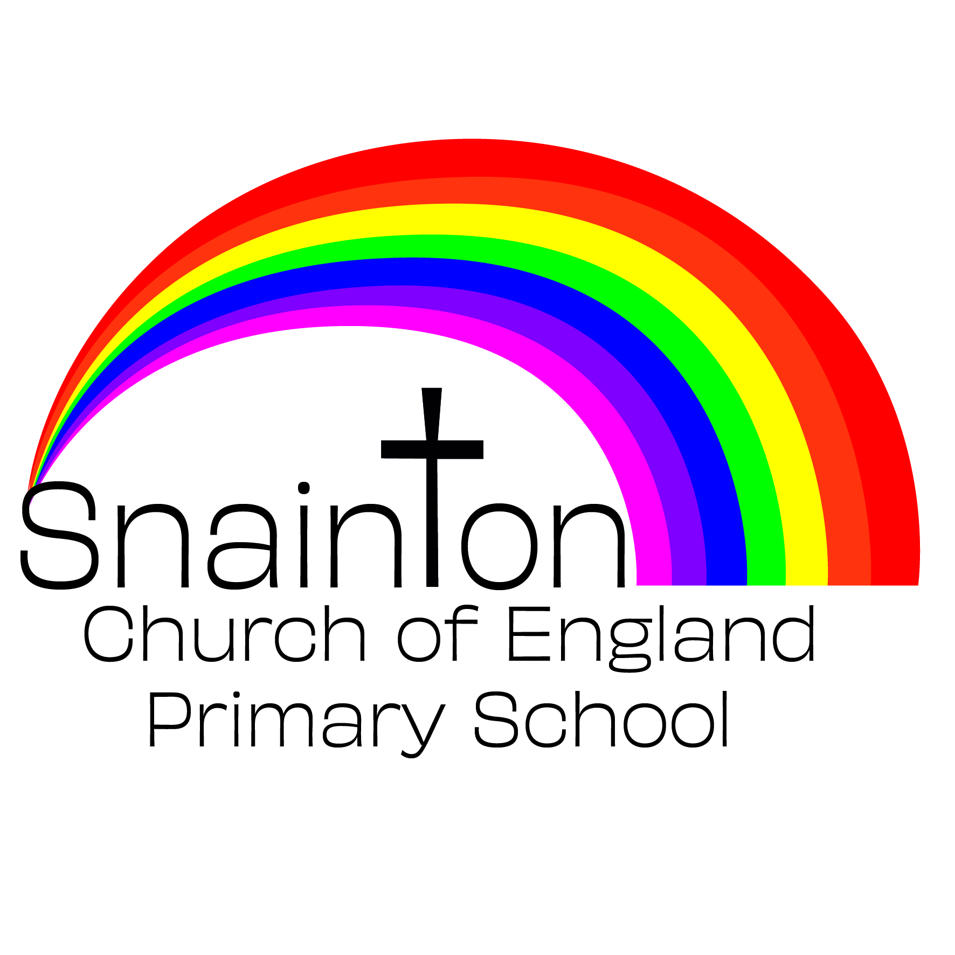

Belong Believe Become
“Do not be afraid: keep on speaking, do not be silent. For I am with you”
Acts 18:9-10

Charging and remissions policy

Approved by governors: 25th January 2021
Date for review: July 2022

INTRODUCTION
All the education we provide during typical school hours is at no charge to pupils. We do not charge for any activity undertaken as part of the National Curriculum. However, we may charge for some additional activities as outlined in this policy.
Aims and Objectives
The aims of this policy will:
- set out what the school will not charge for, what it will make a charge for or request a voluntary contribution from parents/carers;
- clarify how charges will be determined, so parents and carers understand why requests for payment are sometimes made for some activities.

VOLUNTARY CONTRIBUTIONS
When organising school trips or visits to enrich the curriculum and the educational experience of the children, the school invites parents and carers to contribute to the cost. All contributions are voluntary. If we do not receive sufficient voluntary contributions, we may cancel a trip. If a trip goes ahead, it may include children whose parents or carers have not paid any contribution. We do not treat these children differently from any others.
If a parent wishes their child to take part in a school trip or event, but is unwilling or unable to make a voluntary contribution, we do allow the child to participate fully in the trip or activity. Sometimes the school pays additional costs in order to support the visit. Parents and carers have a right to know how each trip is funded, and the school provides this information on request.
The following is a list of additional activities, organised by the school, which may require voluntary contributions from parents and carers. These activities are known as “optional extras”. This list is not exhaustive:
- visits to museums;
- fieldtrips and research visits;
- sporting activities which require transport expenses;
- outdoor adventure activities;
- visits to or by a theatre company;
- school trips;
- musical events.

RESIDENTIAL VISITS
If the school organises a residential visit in school time, or mainly in school time, which is to provide education in addition to the National Curriculum, we do charge travel expenses and for the costs of board and lodging, although parents and carers who receive state benefits are exempt from this board and lodging charge if an NYCC centre is used.

MUSIC TUITION
All children study music as part of the normal school curriculum. We do not charge for this.
There is a charge for individual or small-group music tuition, since this is an additional curriculum activity, and not part of the National Curriculum. These individual or small-group lessons are taught by peripatetic music teachers (Local Authority & Private). Private lessons are at cost to parents / carers. NYCC make a charge for Local Authority lessons, but parents and carers in receipt of state benefits may be exempt from payment. We give parents and carers information about additional music tuition at the start of each academic year.

SWIMMING
Snainton Church of England Primary School organises swimming lessons for children in Reception – Year 6. These take place in school time and are part of the National Curriculum. We make no charge for this activity. However, the cost of transport is usually covered by the Parent Teacher Association. If this is not possible, a voluntary contribution may be requested from parents and carers.

ADDITIONAL SPORTS COACHING
Snainton Church of England Primary School is sometimes able to secure the services of a qualified sports coach. The cost of Sports Funding that is part of the PE Curriculum Provision is funding by the Sports Premium Funding delegated to schools from the DfE.
Monitoring and review
This policy is monitored by the governing body, and will be reviewed every three years or sooner if necessary.

