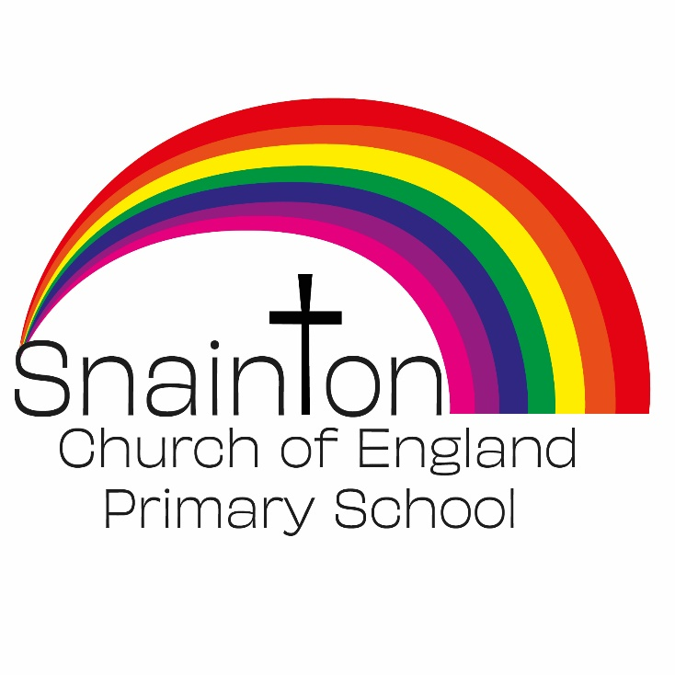

Belong Believe Become
“Do not be afraid: keep on speaking, do not be silent. For I am with you”
Acts 18:9-10

Curriculum Intent Statement
Art and Design

Art, craft and design embody some of the highest forms of human creativity. A high-quality art and design education should engage, inspire and challenge pupils, equipping them with the knowledge and skills to experiment, invent and create their own works of art, craft and design. As pupils progress, they should be able to think critically and develop a more rigorous understanding of art and design. They should also know how art and design both reflect and shape our history, and contribute to the culture, creativity and wealth of our nation.

At Snainton Church of England Primary School we intend to…
- Produce creative work, exploring our ideas and recording our experiences.
- Become proficient in drawing, painting, sculpture and other art, craft and design techniques.
- Evaluate and analyse creative works using the language of art, craft and design.
- Know about great artists, craft makers and designers, and understand the historical and cultural development of their art forms.

