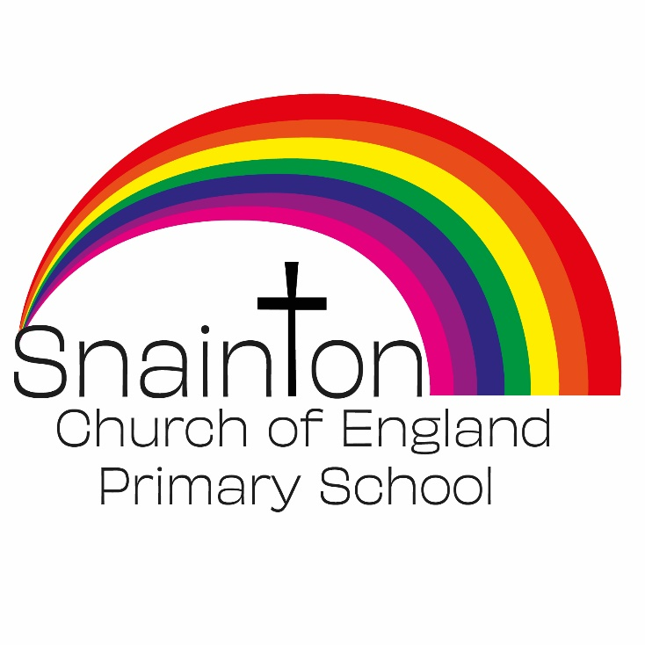

Belong Believe Become
“Do not be afraid: keep on speaking, do not be silent. For I am with you”
Acts 18:9-10

Curriculum Intent Statement
English

English has a pre-eminent place in education and in society. A high-quality education in English will teach pupils to speak and write fluently so that they can communicate their ideas and emotions to others and through their reading and listening, others can communicate with them. Through reading in particular, pupils have a chance to develop culturally, emotionally, intellectually, socially and spiritually. Literature, especially, plays a key role in such development. Reading also enables pupils both to acquire knowledge and to build on what they already know. All the skills of language are essential to participating fully as a member of society; pupils, therefore, who do not learn to speak, read and write fluently and confidently are effectively disenfranchised.

At Snainton Church of England Primary School we intend to …
- Ensure that all pupils can read easily, fluently and with good understanding.
- Develop the habit of reading widely and often, for both pleasure and information.
- Acquire a wide vocabulary, an understanding of grammar and knowledge of linguistic conventions for reading, writing and spoken language
- Appreciate our rich and varied literary heritage.
- Write clearly, accurately and coherently, adapting their language and style in and for a range of contexts, purposes and audiences.
- Use discussion in order to learn; they should be able to elaborate and explain clearly their understanding and ideas.
- Be competent in the arts of speaking and listening, making formal presentations, demonstrating to others and participating in debate.

English Language and Literacy
Implementation
At Snainton Church of England Primary school we take a text base approach to teaching the English Language and Literacy. High quality texts are selected to provide the context for language development at vocabulary and sentence level. The texts also provide the context and the link for teaching grammar and punctuation.
In Nursery, books are carefully selected for the ages and developmental stages of the children making sure that the 2-3 and 3-4 year-olds are provided with the language that is suitable for their understanding but also exposing them to new environments, events and people that they may not experience otherwise. Teachers will model new language from stories and consciously use vocabulary in different contexts so it can become part of the children’s vocabulary. Teachers will also find a point of reference in children’s play and describe what the children are doing in the moment, hence giving children the tools to be able to understand and describe their own actions. Talk Through Stories is used throughout the school to develop a repertoire of shared texts for all children.
In both classes, KS1 and KS2, texts are selected to cover cross curricular topics but also making sure that they are high quality to develop children’s language skills and grammar. They also introduce children to different genres of writing which they can use to develop their own skills as competent writers:
The sequence of teaching follows a pattern of:
1. Engage with the genre of writing and explore typical features.
2. Teach new vocabulary and sentence structures.
3. Introduce grammatical structures and punctuation.
4. Practice newly learnt skills through shared and guided writing.
5. Plan and Produce an independent piece of work reflecting what has been learnt.
6. Edit and make improvements to their work.
The final piece of writing provides evidence for assessment and for future planning.

Impact
At Snainton Church of England Primary School children have the knowledge and skill to be able to write successfully for a purpose and audience. With the implementation of the writing sequence being established in both Key stages, children are becoming more confident writers and have the ability to plan, draft and edit their work. By the end of KS2 children enjoy sustained writing and can manipulate language, grammar and punctuation to create effect.

Phonics and Reading
At Sainton Church of England Primary School, early reading and phonics are taught through Little Wandle, a high quality systematic and synthetic phonics programme.
In Nursery, children develop a love of stories through our growing collection of books that are carefully selected to reflect the ages and developmental stages of this age group. As well as the daily story time, adults read to individual children. This may be initiated by the children themselves or may be initiated by the teacher to encourage a child to interact with books and learn positive reading behaviours.
Children are prepared for phonics by games and activities that develop their listening skills, hearing sounds, sequencing skills and memory. This is supported by the document ‘Foundations of Phonics’ provided by Little Wandle as part of the whole school phonics approach.
In Reception and KS1, to ensure fidelity to the ‘Little Wandle phonics programme’, we fully adopted the recommended Phonics and Early reading policy. This document outlines in detail how phonics and reading is taught in our school.
In Year2, those children who have moved beyond the phonics programme and finished the accompanying books, select reading books from our reading library. Comprehension is developed through visualising techniques and discussions about what children have read. Children are encouraged to identify vocabulary and language they are not familiar with to discuss with their teacher.

