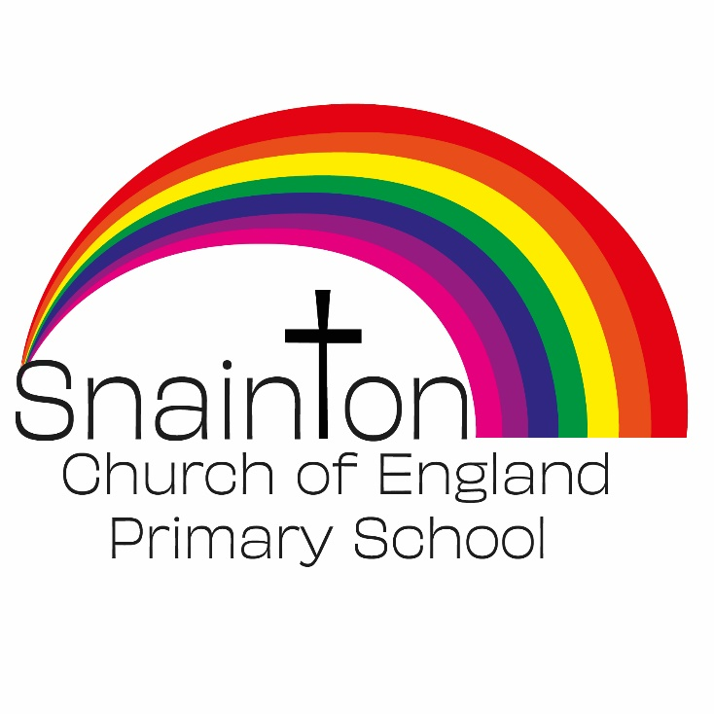

Belong Believe Become
“Do not be afraid: keep on speaking, do not be silent. For I am with you”
Acts 18:9-10

Curriculum Intent Statement
History

Intent
In History, pupils are encouraged to question their understanding of the past and gain an in-depth understanding of significant events in British history as well as appreciating how things change over time. History helps pupils to understand the complexity of people’s lives, the process of change, the diversity of societies and relationships between different groups, as well as their own identity and the challenges of their time.

At Snainton Church of England Primary School we intend to …
- Create a sense of curiosity about how and why events in the past happened.
- Raise questions as to what could have happened if events had a different result.
- Reflect on different interpretations of the past and how these interpretations have been arrived at.
- Comment on moral questions and dilemmas such as those that would be unacceptable today.
- Explore the similarities and differences between past and present societies.
- Gain an understanding of and empathise with people from different cultural backgrounds.
- Examine how other cultures have had a major impact on the development of ’British’ culture.
- Develop a better understanding of our multicultural society through studying links between local, British, European and world history.

Implementation
In nursery children develop their sense of History by talking about past events in their own lives, their families and other people they know. Children are encouraged to develop a sense of change over time and are given opportunities to differentiate between past and present by observing routines throughout the day and throughout the week. Children grow plants, observe passing of seasons, look at photographs of themselves in past situations. Teachers model language relating to time used in conversations like; yesterday, old, past, now and then and encourage children to use them in context of retelling of past events.
In KS1, History units are planned across 4 years to fit a cross curricular theme. There are four history topics planned each year with one topic focusing on a local aspect. Each session is built around a key question. During the lessons children acquire new knowledge and practice and develop skills to answer the posed question. Wherever possible, learning is enhanced by the use of artefacts and visits to make history come to life.
Similarly, in KS2, the History curriculum is planned over a 4 year rolling programme to ensure coverage of the National curriculum. History is not taught in chronological order, so every effort is made that children understand how and where the studied period fits in the timeline of history. Lessons are based around a Key question and children learn new knowledge and develop skills to answer the questions. Links are often made within topics to promote diversity and address our varied cultural heritage.

Impact
Children will become increasingly critical and analytical within their thinking. They will be making informed and balanced judgements based on their knowledge of the past.
Children will become increasingly aware of how historical events have shaped the world that they currently live in.
Children will develop enquiry skills to pursue their own interests within a topic by further questioning.
Children will have an understanding of their history and of their place in Britain and the wider world.

