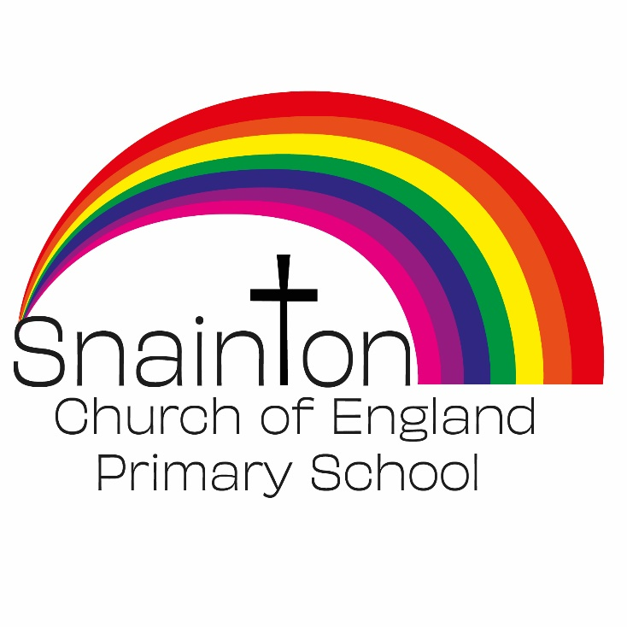

Belong Believe Become
“Do not be afraid: keep on speaking, do not be silent. For I am with you”
Acts 18:9-10

Curriculum Intent Statement
Languages

Learning a foreign language is a liberation from insularity and provides an opening to other cultures. Learning languages fosters pupils’ curiosity and deepen their understanding of the world. It enables pupils to express their ideas and thoughts in another language and to understand and respond to its speakers, both in speech and in writing. It provides opportunities for them to communicate for practical purposes and learn new ways of thinking.

At Snainton Church of England Primary school we intend to …
- Understand and respond to spoken and written language from a variety of authentic sources.
- Speak with increasing confidence, fluency and spontaneity, finding ways of communicating what they want to say, including through discussion and asking questions, and continually improving the accuracy of their pronunciation and intonation.
- Write at varying length, for different purposes and audiences, using the variety of grammatical structures that they have learnt.
- Discover and develop an appreciation of a range of writing in the language studied.

