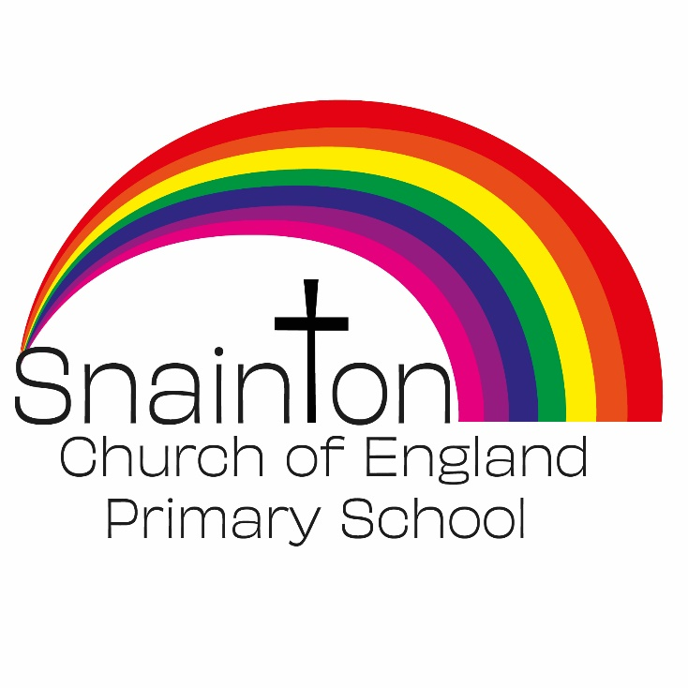

Belong Believe Become
“Do not be afraid: keep on speaking, do not be silent. For I am with you”
Acts 18:9-10

Curriculum Intent Statement
Mathematics

Mathematics is a creative and highly inter-connected discipline that has been developed over centuries, providing the solution to some of history’s most intriguing problems. It is essential to everyday life, critical to science, technology and engineering, and necessary for financial literacy and most forms of employment. A high-quality mathematics education therefore provides a foundation for understanding the world, the ability to reason mathematically, an appreciation of the beauty and power of mathematics, and a sense of enjoyment and curiosity about the subject.

At Snainton Church of England Primary School we believe that everyone has the ability to achieve their potential.
We intend for pupils to …
- Become fluent in the fundamentals of mathematics through varied and frequent practice.
- Develop conceptual understanding and the ability to recall and apply knowledge rapidly and accurately.
- Reason mathematically by following a line of enquiry, conjecturing relationships and generalisations.
- Develop justification or proof using mathematical language.
- Solve problems by applying their mathematical understanding to a variety of routine and nonroutine problems.

Implementation
At Snainton Church of England Primary School Mathematics is taught through the Mastery approach.
In Nursery, children encounter numbers in their everyday lives. They learn to say numbers in order through songs and rhymes and stories. Teachers use everyday situations to provide opportunities for counting in context. Activities range from counting cars in a line to counting cups for snack time. Children learn to point at objects as they count and they solve problems by checking if they have enough plates for everyone. These activities lay the foundations for understanding number.
In Reception, teaching and learning is based on the Mastering Number programme as set out by NCETM. Children are taught through small group work and apply their learning through continuous provision.
Teaching develops the concept of cardinality, ordinality, counting, comparison and subitising. Through this approach children develop a deep understanding of number and lay the foundations for their future learning in mathematics.
Classes from Year 1 to Year 6 follow the White Rose scheme of learning which is based on the National curriculum. However, lessons can be adapted to address the needs of individual or groups of children as required.
Concepts are introduced through the concrete, pictorial and abstract sequence. A range of manipulatives are used in lessons to secure understanding and support children in their reasoning.
The teaching of fluency, reasoning and problem solving provides the structure for lessons to achieve a balanced approach and develop the necessary skills to be able to solve and reason about mathematical problems.
Mathematical vocabulary and the use of stem sentences support children in communicating their understanding clearly.

Impact
At Snainton Church of England Primary School the expectation is that the majority of pupils will move through the programmes of study at broadly the same pace.
We aim for each child to be confident in each yearly objective and develop their ability to use this knowledge to develop a greater depth understanding to solve varied fluency problems as well as problem solving and reasoning questions.
However, decisions about when to progress should always be based on the security of pupils’ understanding and their readiness to progress to the next stage. Pupils who grasp concepts rapidly are challenged through problems that will deepen their understanding before moving onto new content.
Those who are not sufficiently fluent will consolidate their understanding, including through additional practice, before moving on.
Teachers carry out formative assessment through AfL in each session and feedback is given to children verbally, through self/peer assessment and through marking. Teachers then use this assessment to influence their planning. Children are rapidly identified as needing further challenge or additional support, and we ensure that this is provided in a timely manner.
Summative Assessment takes place at the of each unit of learning. Children complete End of Block assessments for each unit. Results are used to further inform planning and allow for tailored interventions groups to take place to ensure the objectives are secured.

