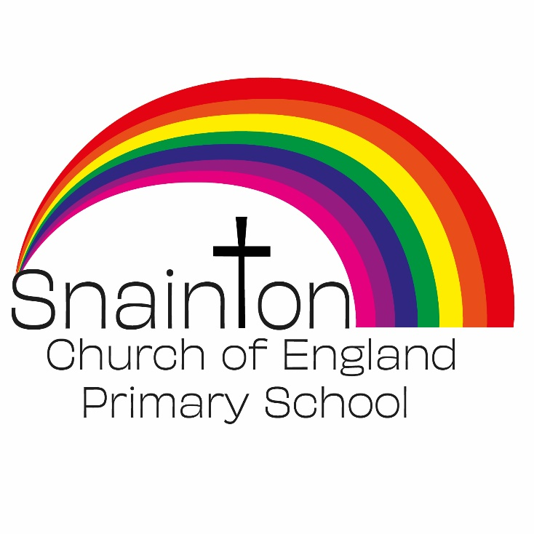

Belong Believe Become
“Do not be afraid: keep on speaking, do not be silent. For I am with you”
Acts 18:9-10

Curriculum Intent Statement
Music

Music is a universal language that embodies one of the highest forms of creativity. A high quality music education should engage and inspire pupils to develop a love of music and their talent as musicians, and so increase their self-confidence, creativity and sense of achievement. As pupils progress, they should develop a critical engagement with music, allowing them to compose, and to listen with discrimination to the best in the musical canon.

At Snainton Church of England Primary School we intend to …
- Perform, listen to, review and evaluate music across a range of historical periods, genres, styles and traditions, including the works of the great composers and musicians.
- Learn to sing and to use their voices, to create and compose music on their own and with others, have the opportunity to learn a musical instrument, use technology appropriately and have the opportunity to progress to the next level of musical excellence.
- Understand and explore how music is created, produced and communicated, including through the inter-related dimensions: pitch, duration, dynamics, tempo, timbre, texture, structure and appropriate musical notations

