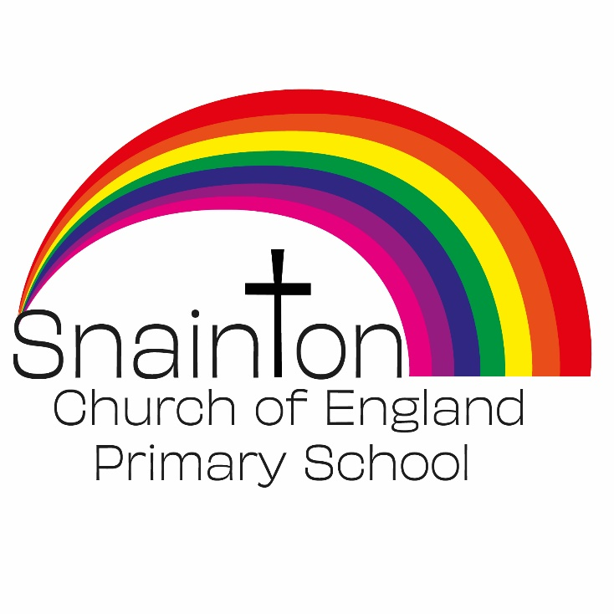

Belong Believe Become
“Do not be afraid: keep on speaking, do not be silent. For I am with you”
Acts 18:9-10

Curriculum Intent Statement
Physical Education

PE plays a vital role in promoting physical activities and a healthy lifestyle in a positive and enjoyable way for all pupils.

At Snainton Church of England Primary School we intend to…
- Develop and challenge pupils’ abilities in a range of physical activities and sports
- Help them develop their personal fitness
- Lead healthy, active lives
- Learn important life skills such as teamwork, honesty and perseverance.

