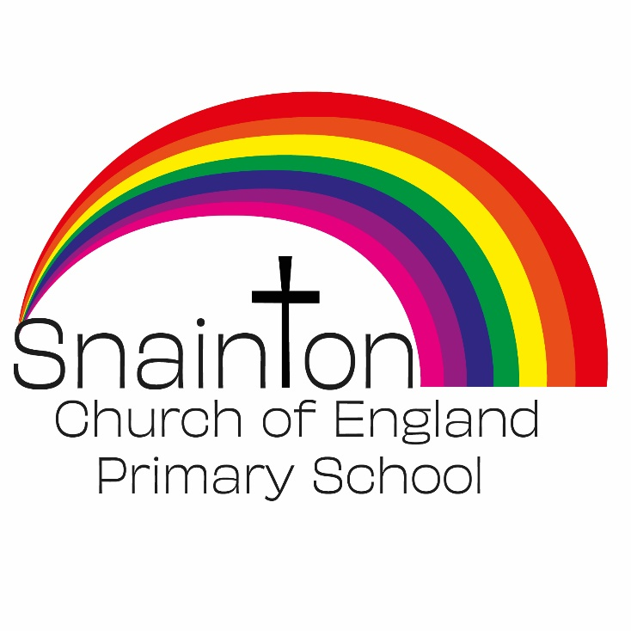

Belong Believe Become
“Do not be afraid: keep on speaking, do not be silent. For I am with you”
Acts 18:9-10

Curriculum Intent Statement
Religious Education

Religious Education plays a significant role in the development of pupils’ spiritual, moral, social and cultural development. It promotes respect and open-mindedness towards one another and encourages pupils to develop their sense of identity and belonging through self-awareness and reflection.

At Snainton Church of England Primary school we intend to…

- Encourage our pupils to explore questions arising from their study of religion, faith and belief to promote their personal, spiritual, moral, social and cultural development.

- Provide our pupils with the knowledge and understanding of Christianity and other principal religious faiths, traditions and beliefs represented in Great Britain and the wider world.

- Encourage our pupils to explore their own beliefs (religious or non-religious), in the light of what they learn and enable them to build their sense of identity and belonging, which helps them flourish within their communities and as citizens in a diverse society.

- Teach our pupils to develop respect for others, including people with different faiths and beliefs, and help to challenge prejudice.

- Prompt our pupils to consider their responsibilities to themselves and to others, and to explore how they might contribute to their communities and to wider society.

- Encourage empathy, generosity and compassion.

- Develop a sense of awe, wonder and mystery.

- Nurture each child’s own spiritual development.

