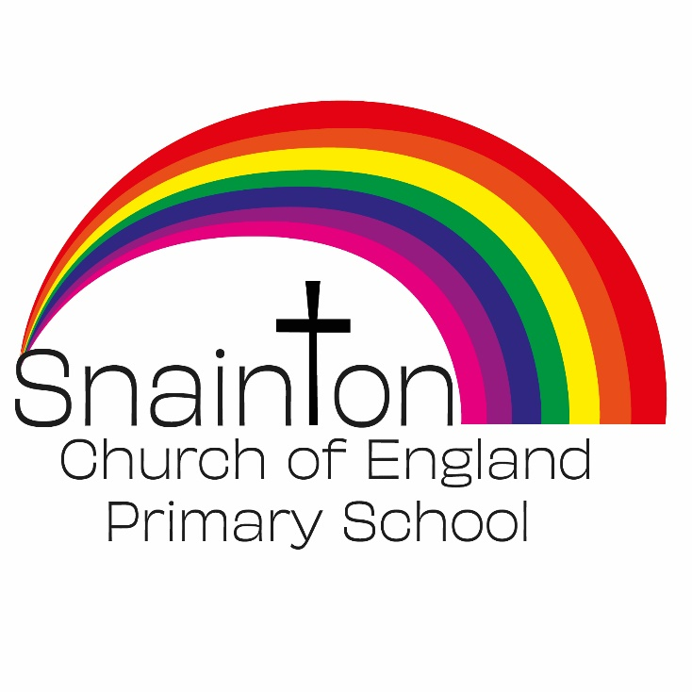

Belong Believe Become
“Do not be afraid: keep on speaking, do not be silent. For I am with you”
Acts 18:9-10

Curriculum Intent Statement
RSE

Personal, Social, Health and Economic (PSHE) education is a school subject through which pupils develop the knowledge, skills and attributes they need to manage their lives, now and in the future. It helps children and young people to stay healthy and safe, while preparing them to make the most of life and work.

At Snainton Church of England Primary School we intend to …

• Better understand the nature of human relationships.
• Learn about relationships, the importance of communication and of values such as respect (for self and others), equality, responsibility, care and compassion.
• Reflect upon the importance of stable and loving relationships for family life, including the bringing up of children, this also includes marriage and civil partnerships.
• Consider and understand the changes that occur to their bodies, minds and emotions as a consequence of growth from childhood to adulthood.
• Reflect upon how to make good, informed and safe choices concerning relationships and healthy lifestyles.

Implementation

In Nursery, Children are supported to manage their emotions, develop a positive sense of self, set themselves simple goals, have confidence in their own abilities, to persist and wait for what they want and direct attention as necessary. Through adult modelling and guidance, they will learn how to look after their bodies, including healthy eating, and manage personal needs independently. Through supported interaction with other children, they learn how to make good friendships, co-operate and resolve conflicts peaceably.

Our KS1 and KS2 PSHE curriculum is based on the PSHE Association Programme of Study which has 3 strands:
- Health and Wellbeing
- Relationships
- Living in the Wider World

The curriculum coverage is planned over a 2-year rolling programme (KS1) and over 4-year rolling programme (KS2) in our mixed age classes and it is taught through specific lessons and through other curriculum areas such as Science, RE and PE.

PSHE lessons have a specific place on the timetable and each unit will be delivered over half a term.
Lessons are designed to be delivered in a creative and stimulating way, incorporating a range of approaches such as scenarios, discussions, drama and games. This ensures that the lessons are inclusive and can meet the needs of all children.
At the start of each lesson the ‘Ground Rules’ are revisited to provide a safe and supportive learning environment where children can explore and discuss topics of interests freely and without prejudice. Each child has a right to pass.
As part of our Relationship and sex education
• KS1 being taught the names for different body parts which include the names for
external genitalia.
• Year 1 / 2 / 3’s are taught about what physical contact is acceptable or unacceptable. This is vital to support the work we do in keeping all pupils safe. Pupils need to have the language to describe the private parts of their body and learn that their body belongs to them, they have a right to say no both on and offline (consent), and that they should tell an adult if they’re upset or worried. To support us in delivering this message to the pupils we use information from the NSPCC Underwear Rule campaign. http://www.nspcc.org.uk/
• In Year 4-6 pupils start to learn that their body and emotions will change as they get older and continue to build on learning about the key components of a healthy relationship and how to keep themselves safe both on and off line. This learning continues in Year 5 and 6
• In Year 4-6 pupils learn about all the external and internal genitalia and the ways in which children grow and develop in puberty both physically and emotionally.
• In Year 5-6 pupils further develop their understanding of the physical and emotional changes they go through at puberty and about human reproduction.

Impact

Through a pre-assessment activity the class teacher is able judge the direction the learning needs to take place and the post-assessment activity is a good indicator of progress made in the lesson.
The PSHE curriculum will have a positive impact on children’s health and wellbeing and their ability to achieve. It will prepare them for the challenges, opportunities, and responsibilities of adult life. Learners will develop a good understanding about safety and risks in relationships. They will be prepared for the physical and emotional changes they undergo during puberty.

