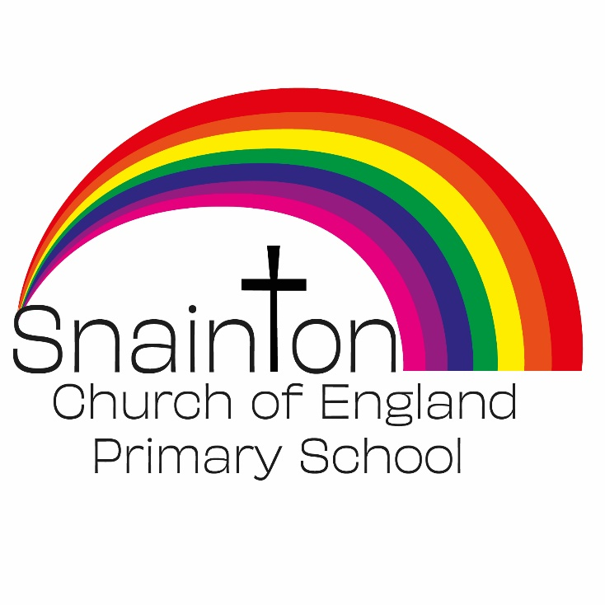

Belong Believe Become
“Do not be afraid: keep on speaking, do not be silent. For I am with you”
Acts 18:9-10

Curriculum Intent Statement
Science

Science is the study of nature and how things work, the reasons behind every-day things. It’s about making strange, mysterious, and complicated things become things we understand. It is about measuring and testing things and trying to find rules about how things work by testing them fairly. Working scientifically helps develop critical thinking skills, and has lots of links to other subjects, especially Maths and Design Technology. Science should inspire, enthuse and enable children to find out about the world around them and how it works.

At Snainton Church of England Primary School we intend to …
- Grow as scientists.
- Make our learning hands-on and practical through enquiry-based investigations and effective use of outdoor areas.
- Encourage children to find answers to their own questions and provide them with the tools to think critically.
- Use scientific vocabulary to help explain our learning.
- Encourage children to think about how Science relates to their everyday lives.
- Encourage children to ask questions about the world around them and empower them to answer these questions using scientific thinking.

Implementation
At Snainton Church of England Primary school scientific learning begins in nursery. Children explore the world around them though a hands-on approach. They use our local environment to go on nature walks, grow vegetables or observe the weather. Learning is often planned through stories but it can also take place ‘in the moment’ through children’s interest. Teachers engage in conversation and describe what children are seeing, doing or experiencing giving them the vocabulary and language skills to develop their understanding.
At KS1 and KS2 Science is delivered over a two-year rolling programme. Wherever possible, Science topics are selected to fit into a cross curricular structure. However, where no link can be made, Science it taught as a stand-alone unit.
At Snainton Church of England Primary School, we have been inspired by the work of Nicky Waller. Her book,’ A Creative Approach to Teaching Science’ advocates a creative, hands-on approach to motivate and challenge children while covering the requirements of the National curriculum. Through this approach we can ensure that our curriculum delivers for the wide age range (Year R - Year2 and Year3-6) within our classes. The book contains a wealth of exciting and unusual activities that have been tried and tested and ensures the progression of the statutory requirements for primary science.
Each unit is planned over a half term. Every session begins with an enquiry question and the aim of the lesson is to build on existing knowledge, acquire knew knowledge, apply it and come to a conclusion by answering the question paused at the beginning of the lesson.
In a mixed age class, children will have different starting points which is established by the class teacher at the beginning of the unit to be able to support children and plan precisely for their learning journey.
Forest School and our local environment provide an excellent real-life context for our children to be able to practice and apply their scientific knowledge and skill.
At Snainton Church of England Primary School we regularly take part in ‘Science week’ projects to promote the love of science and the importance of STEM.
Formative assessment is used as the main tool for assessing the impact of science as it allows for misconceptions and gaps to be addressed more immediately rather than building on insecure scientific foundations.

Impact
The enquiry-based approach to the teaching of science at Snainton Church of England Primary School will result in a fun, engaging, high quality science education, that provides children with the foundations for understanding the world that they can take with them once they complete their primary education.

Children at Snainton Church of England Primary School will:
- demonstrate a love of science
- retain knowledge that is pertinent to Science with a real life context.
- be able to question ideas and reflect on knowledge.
- be able to articulate their understanding of scientific concepts and be able to reason scientifically using rich language linked to science.
- Be able to organise, record and interpret results.
- work collaboratively and practically to investigate and experiment.

