

Belong Believe Become
“Do not be afraid: keep on speaking, do not be silent. For I am with you”
Acts 18:9-10

Behaviour Policy

Approved by governors: 17th November 2025
Date for review: September 2026

Introduction
Snainton Church of England Primary School has reviewed this policy in the Autumn Term 2023. The school council were instrumental in the consultation process by liaising with the Headteacher and their peers to ascertain the areas for improvement as a whole school. Staff completed their own review of the previous behaviour policy to identify elements that were successful, as well as the areas for further improvement. During a consultation with parents, their views identified aspects of this policy that was agreed upon, and all parents were supportive of the need for this revised behaviour policy. Governors completed their own thorough review of this new behaviour policy before adopting it.

Aims
As a school, we aim for all children to:
- Develop a deep understanding of the example of Jesus in The Bible
- Develop their own sense of self and grow in confidence
- Understand that everyone is unique and accept differences
- Take responsibility for their own behaviour
- Be the change they want to see in the World

Principles
As a school, we have a welcoming ethos and celebrate the role that each individual has in sharing that ethos with the wider community. We strongly believe in a child’s right to learn and to fulfil their potential. Our Christian Values (Friendship, Perseverance, Trust, Forgiveness, Community and Respect) underpin the school curriculum and our children develop a deep understanding of how these are rooted in the teachings of The Bible.

Staff aim to:
- Provide clear expectations for all children
- Be encouraging of children’s efforts rather than outcome alone
- Recognise the vital role of parents/carers in each child’s development
- Understand that each child can learn from mistakes

Expectations
The 3 R’s have been adopted to ensure that expectations are clear and memorable. A dual coding system pairs text with an image to ensure that it is accessible for all children. These are presented on a poster (Appendix 1) within each classroom to serve as a reminder for all children and to be a reference point for staff. Staff discuss the understanding of the school expectations with all children at regular intervals in the school year.
Are you…
Ready to learn?
- Sitting in your place
- Listening
- Engaged with learning
Respectful?
- Towards property
- Other people
Responsible?
- Following instructions
- Being helpful

Reward
A strong emphasis is placed on staff having positive relationships with the children. These are developed through mutual respect and by staff modelling the expectations of the school. Staff know the children well in school and learn to adapt their approaches to best build a rapport with individual children.
School aspires to develop an intrinsic aspiration within all children to meet, and exceed, expectations. In doing this, children will develop their own sense of pride and confidence in doing this because it leads to their own success. We believe this approach will help our children to develop the confidence and aspiration to ‘be the change they want to see in the World’.
School also recognises that rewards are needed to support children in recognising their own achievements. To this end, rewards should be in keeping with the achievement made by an individual child. A poster (Appendix 2) is visible in each classroom so that children and adults can use it to recognise when rewards should be given to children.

Consequences
There are times when children will not meet the expectations school has of them. We accept that this can be a typical part of learning, growing and maturing. School aims for consequences to be brief and provide opportunity for each child to modify inappropriate behaviour (see appendix 3). Consequences must only be given alongside a reminder that adults have confidence in a child’s ability to meet, and exceed, school expectations.

Follow up
School involves parents/carers in the response to any need to regularly provide consequences for a child. Thresholds are in place (Appendix 4) that enable staff to engage parents in discussion to identify specific methods for supporting individual children. This holistic approach ensures that each child feels fully supporting in their learning journey. Should the need for referrals to external agencies be required, consent from parents/carers will be sought as part of this follow up approach.

Special Educational Needs and Disabilities
This policy may be adapted for those children with Special Educational Needs and Disabilities (SEND). We recognise that some pupils may have social, emotional and behavioural needs that require proportionate amendments to provision to enable them to access the curriculum alongside their peers. In these cases, a specific support plan and risk assessment will be created with input from parents and external agencies. These plans will be reviewed at least termly by the SENDCo.

Leaving the school site
In the very unlikely event of a child leaving the school site, a member of staff would observe the child from a distance whilst attempting to engage the child in positive dialogue. They would not follow the child closely as this could result in the child running and potentially increasing the risk of an accident. A member of staff within the school building will contact the parents/carers and the police as soon as possible to notify them of the situation.

Exclusion
In very rare circumstances, the Headteacher may decide that specific incidents require fixed term exclusion. This decision will only be made after considering national guidance on exclusions and with the best interests of each child in mind. Incidents that may result in fixed term exclusion include physical assault against an adult/child, verbal abuse towards an adult/child, bullying, racist abuse, sexual misconduct, drug/alcohol incidents, damage to property, theft, persistent disruptive behaviour.
Appendix 1 – expectations poster
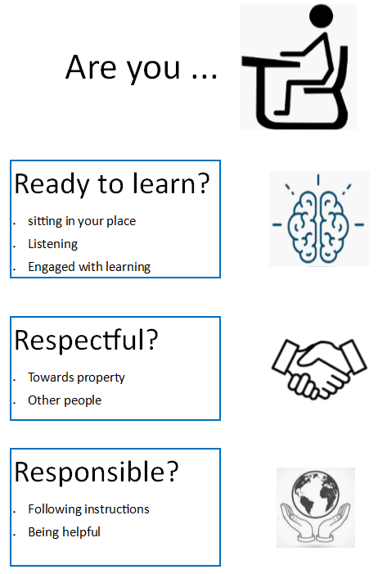

Appendix 2 – rewards poster
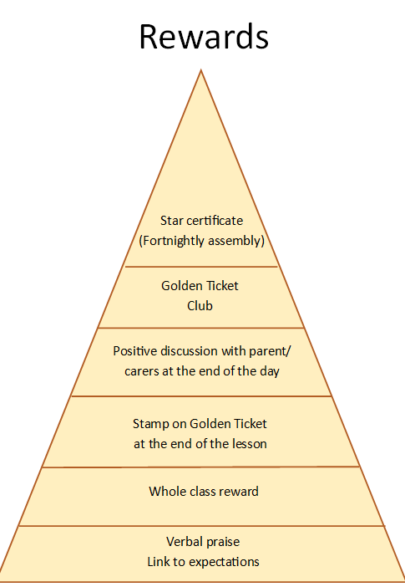

Appendix 3 – consequences poster
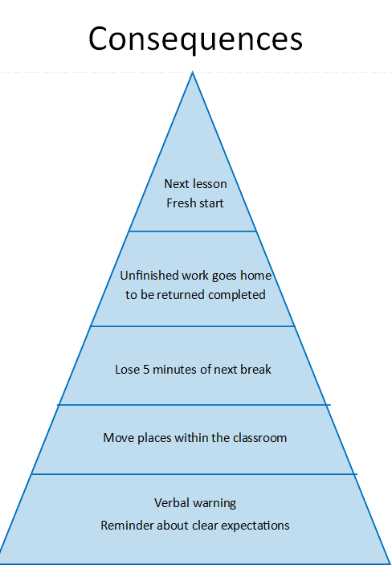

Appendix 4 – follow up (not displayed in classrooms)
